**DIGITAL VISITOR COUNTER**

**PROJECT REPORT**

Submitted for the course: Digital Logic And Design (CSE 1003)

By

**(Name of students with reg. number)**

|  |  |
| --- | --- |
| **VISHAL BHASKAR** | **15BCE0048** |

**Name of faculty: Prof. J SAIRABANU**

**(SCHOOL OF COMPUTING SCIENCES AND ENGINEERING)**



**MAY,2016**

**ABSTRACT**

This project titled “Digital Visitor counter” is designed and presented in order to count the visitors of an auditorium, hall, offices, malls, sports venue, etc. The system counts both the entering and exiting visitor of the auditorium or hall or other place, where it is placed. Depending upon the interrupt from the sensors, the system identifies the entry and exit of the visitor. On the successful implementation of the system, it displays the number of visitor present in the auditorium or hall. This system can be economically implemented in all the places where the visitors have to be counted and controlled. Since counting the visitors helps to maximize the efficiency and effectiveness of employees, floor area and sales potential of an organization, etc.

1. **Introduction:**
   1. **Objective and goal of project:**

This project is based on the topic “Digital Visitor Counter” aiming at creating a new alternative for humans who stand all the times counting the no of items or people who passed the gate. It further aimed at highlighting VIT’s role as a helper for the preparation of it. I tried to cover all the required points decently. I tried to do something new, to show a good alternative for humans in that particular aspect.

* 1. **What is Digital Visitor Counter??**

Digital visitor counter is a reliable circuit that takes over the task of counting Number of Persons/ Visitors in the Room very Accurately. When somebody enters into the Room then the Counter is Incremented by one and when any one leaves the room then the Counter is Decremented by One. The total number of Persons inside the Room is displayed on the seven segment displays.

1. **Components Used:**
   * + 1. Resistors - 1k ohms, 330 ohms, 100k ohms, 47k ohms.
       2. Capacitors ± 0.01uF, 10uF3.
       3. Light Dependent Resistor (LDR)4.
       4. 6V Battery5.
       5. Timer IC555 (2)6.
       6. Decade Counter IC74907.
       7. BCD to 7 Segment Display IC74478.
       8. 7 Segment Display
2. **Circuit Diagram:**

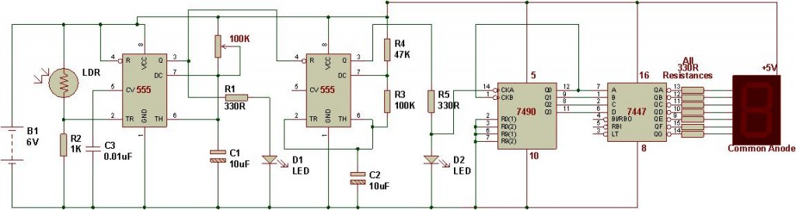

.

1. **STEPS:**

3.1 When the LDR receives a change in the light signal the voltage changes accordingly. Whenever there is light blockage, the resistance increases and the triggering signal is given to the monostable  multivibrator that is first IC555.

3.2 The mono stable mutivibrator generates a high signal which activates the astable multivibrator that is the second IC555. This astable multi vibrator and the other resistors provide the clocking frequency for the decade counter.

3.3 The decade counter IC7490 starts counting the signals and provides the BCD equivalent output.

3.4 The IC 7447 takes BCD as input and converts it into decimal and gives it to the seven segment display.

3.5 Then the seven segment display shows the equivalent counts.

**Conclusion:**

In today’s world there is continuous need of automatic appliances with the increase in the standard of

living there is a sense of urgency of developing circuits that would ease the complexity of life. Also

if one wants to know the number of people present in a room so as not to have congestion one can

use this this circuit to do so.